**Chapter 13 Constraints**

Constraints condition은 자유도와의 관계를 부여하는 것으로 Explicit constraints 는 Transformation equation, Lagrange Multiplier or penalty functions와 같은 형태이다. Implicit constraints의 내용 또한 다룬다.

**13.1 Explicit constraints. Transformation equation**

single-point constraint : 하나의 d.o.f에 known value(때론 0)를 적용하는 것

multipoint constraint :두 개 또는 그 이상의 d.o.f에 known value(때론 0)를 적용하는 것

**Transformation equation to enforce constraints**

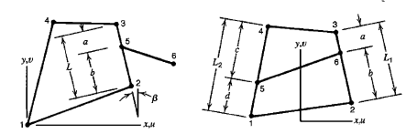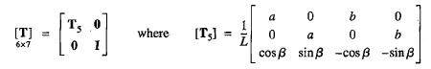

Constraint equations that relate d.o.f in {D}

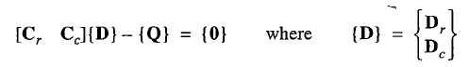{D}는 constraints 에 해당되는 d.o.f보다 항상 같거나 많은 d.o.f을 가지고 있음으로 [C]는 n(column)>n(row)이다.

Partitioning {D} : [Dr Dc]T =>



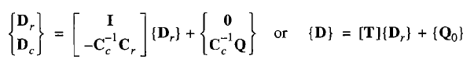

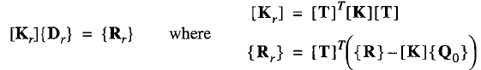

Example :

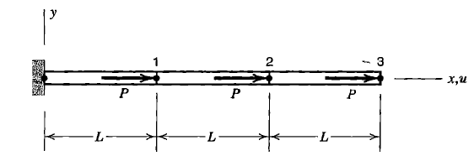 

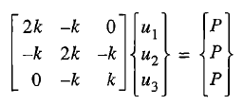

 

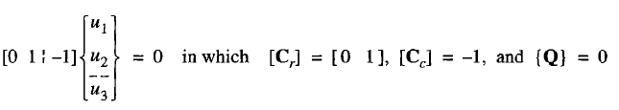 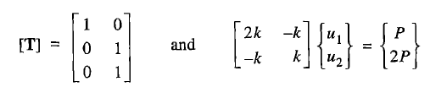



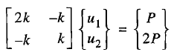 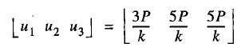

Constraint problem은 known value를 직접 적용하여 transformation equation으로 변형 가능하지만, 난이(considerable bookkeeping, rearrangement of coefficients)하고 이고, 특히 multipoint일 경우 제한성이 심화된다. 그 대안으로

1. Lagrange multiplier method : add number of equation
2. Penalty method : leaves the number of unknowns but produce ill-condition

**13.2 Lagrange multipliers to enforce constraints**

Potential energy function with Lagrange multipliers

,

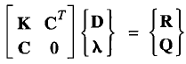

,  =>

Example)

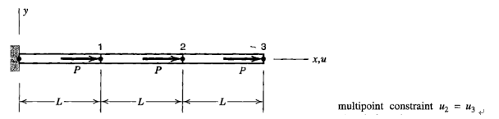

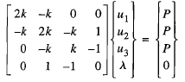

**13.3 Penalty functions to enforce constraints**

Potential energy function with penalty numbers

 , 

The penalty of constraint violation becomes greater as  increases.

 =>

는 penalty matrix. If =Null, constraints are ignored.

를 변경시키며 minimum condition을 만족하는 {D}를 찾는다. 적절한 를 찾는 것이 중요하다. 일반적으로 는 충분히 큰 수이어야만 구속조건이 효과적으로 적용된다. Penalty method는 모르는 변수를 추가하여 equation을 만들진 않지만, ill-condition을 유발할 수 도 있다.

Example

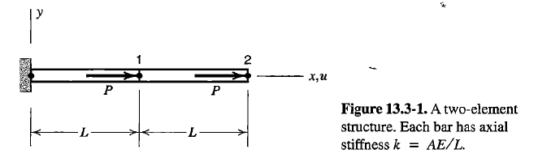

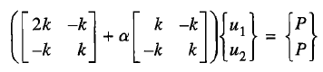

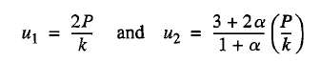

Exact solution =>  -> => contraints를 만족하는 u1 u2를 구한다. =>approximate sol => exact sol

Issue:

구속조건에 의해 [C]의 column수가 row수보다 크게 되고 는 singular matrix가 된다. 단순화 하여 보기 위해 다음과 같이 가정한다면..

, 

⬄

여기서 는 singular matrix이라면 [D]는 Non-zero값을 가진다. 이와 같은 성질은 implicit penalty constraints 에서는 특별하게 더욱 중요한 이슈를 다룬다. 이에 대해서는 13.4절에서 다룬다.

**13.4 Implicit penalty constraints and locking**

Multipoint constraints 는 penalty matrix를 explicit하게 더해줌으로써 적용가능했다. 몇몇 공학문제에서 penalty matrix와 같은 역할을 하는 성질이 formulation에서 내재적으로 생길 수 있다. implicit penalty constraints라 하며, 이에 생길 수 있는 문제는 locking이다.

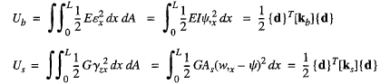Transvers beam formulation

탄성변형에너지 bending

Transvers shear



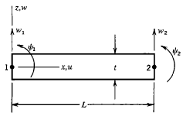

<Mindin Beam Element>

Contribution bending to total deflection =  =>t가 작아진다. => bending 의 기여가 작아지고 Ks의 기여가 커진다. => 는 penalty matrix와 같은 역할을 할 수 있고 이 되어 Locking 현상이 발생한다.

Incompressible Material에서도 비슷한 경향이 보인다

G= Shear modulus, B=Bulk modulus

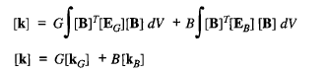

V=0.5가 될 때(Incompressible) 

Locking은 selective integration을 통해 해결 가능하다.

Choice of  : 일반적으로 103 ~104 이고 두배의 정확도를 위해선 106 ~107 의 수가 적당하다.

13.5 Constraints and Quadrature points

General form

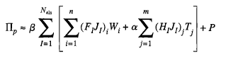

:implicit constraint =>

: penalty number

P: work done by all type loads

Ideal finite element

 

1. Ellipticity (Positive strain energy)

FE should have only 6 zero energy mode corresponding to 6 rigid body motion



Extra zero energy mode 🡪 spurious zero energy mode

2. Consistency: FE is based on mathematical model. As h decrease, the solution of FE model should converge that of the corresponding mathematical model



3. Uniform optimal convergence

🡪 No locking

🡪 Convergence should not depend on material or geometrical property.

Locking: the term “locking” refers to excessive stiffness in one or more deformation modes

1. Volumetric locking (2d-3d plane, solid elements):

Convergence depends on poison ratio, , error increases

, , 

If , very small change strain🡪 big change in pressure(sensitive)

**A pathological case of volume locking in triangular elements**

Consider triangle 1, in Figure 1, which is defìned by nodes 1 and 2 on the x axis, and node 3 on the y axis. The area of the triangle is (x2 - x2)y3/2, and it must remain constant if the triangle is incompressible. If nodes 1 and 2 are ixed, then y3 must remain constant and v3 = 0. The remaining degree of freedom is the horizontal displacement u3. Similarly, for the triangle 2, deined by nodes 4, 5, and 6, the only remaining degree of freedom is the vertical displacement v6.

*Two triangles may be assembled into a quadrilateral region, see Figure 2. Since incompressibility for triangle 1 requires v4 = 0 and incompressibility for triangle 2 requires u4 = 0, node 4 cannot move, and the elements are completely locked up.* With nodes 1 through 4 locked up, the nodes for triangles 3 and 4 will also be locked, as will the ones for triangles 5 and 6, see Figure 3. Again, since all previous triangles are locked, adding triangles

1. 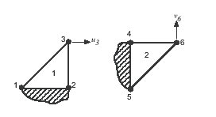

Figure 1: The remaining degrees of freedom for two incompressible constant strain triangles.

1. 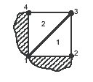

Figure 2: Two incompressible constant strain triangles assembled into a quadrilateral lock.

... 7 and 8 will result in their nodes also being locked. Elements can continue to be added in the same pattern, and all the nodes will be locked. Analogous problems occur in three dimensions with tetrahedral elements.

2. Shear locking (beam, plate, shell, 2d/3d solid): happens in bending problem

Wrong behavior shear strain: as , transverse shear strain overestimate in pure bending

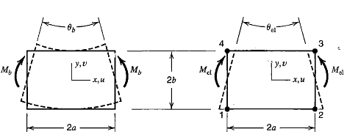

In Q4 elements, element strains are

, , 

In the case of pure bending a block of material has strains

, , 

Ratio of rotation produced is



 approaches zero as aspect ratio increase without limit

3. Membrane locking (Curved beam, shell element): in bending problem

As , membrane strain overestimate in pure bending

Constraint counting

